小故事

中国的地产大亨王老板，李老板，日本的孙老板，美国的川老板想玩一局大富翁决定谁跟厉害。他们玩的一款新大富翁游戏，跟以往不同的是他的变数更多，中途还可以允许别的老板或是企业家加入。于是他们当然选择是最高难度，王老板选择尽快买房铺开地盘，川老板选择卖贵地建高楼，孙老板稳步投资，李老板而是选择尽快购入公司，玩到一半马老板进来了，困难难度下波动率大。川老板因为花太多钱升级地产导致，现金不足，之后走入对手地产，抵押的钱也无法还清债务最后破产。马老板现金多，从银行以相对低的价格拍入原来川老板的房子，迅速在场上占的一席之地。其他老板们也有自己的小心思，决定达成同盟互惠互利，以便打压新进来的马老板。游戏越来越有意思了。

//注释掉脑洞

企业家

1. 企业家可以买公司，从已经拥有地皮的人手中收钱，企业家必须承包一个community chest负责社会福利也就是给经过玩家钱。
2. 传统玩家可以参企业股，经过企业的时候少交钱而且有股息也就是每x轮企业家收到的钱分红。

UML描述

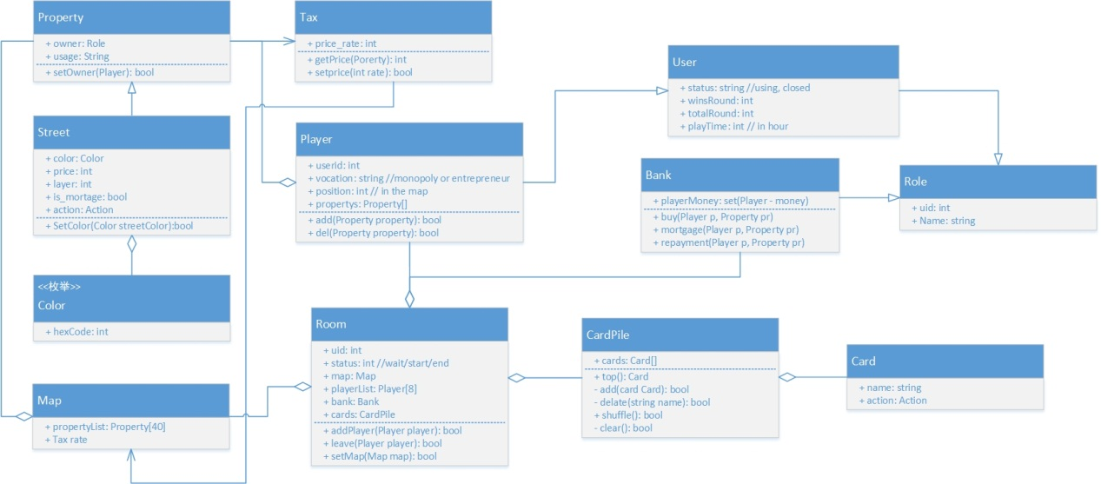

Figure x shows the architecture of the game.

Basically, there are 5 classes: Role, Card, Room, Property, and Map. Class Role includes class User, class Bank. Class Card makes up the card pile of chance and destiny. Class Room keeps all information of a game. Property means all the blocks in the map. And Class Map keeps the information of sequence of the blocks and the global tax rate etc.

Role

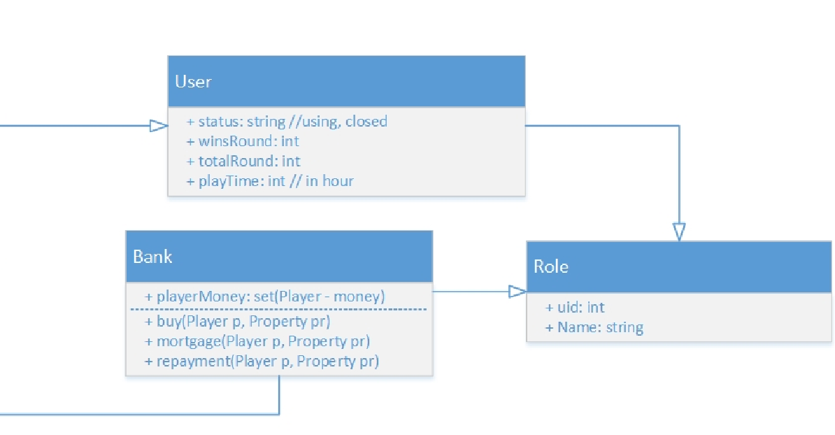 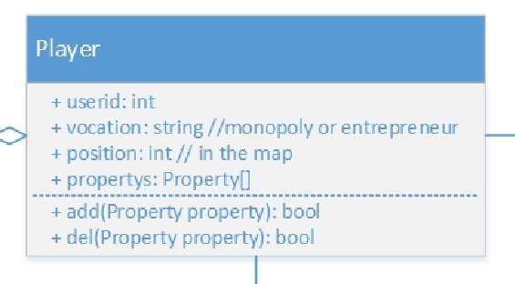

Figure x shows class Player, class User, class Bank, and class Role.

All players in class Player are extended from class User which is extended from class Role. Role just has the attribute of identity and name. Player will keep track his/her vocation, position and properties. User will keep track him/her status, winning probability. Bank will keep track players money in a game. All players should transfer money through the bank.

Card

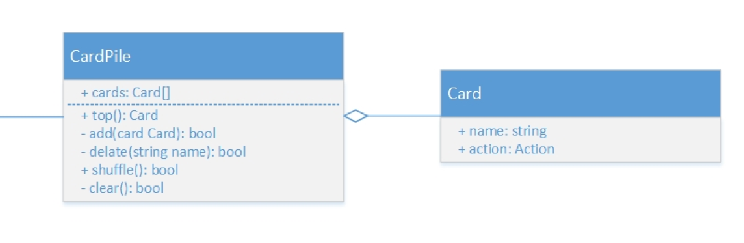

Figure shows class Card pile and class Card.

The actions of chance cards are various. So, we should enumerate each card action. Card piles stores all cards in a game and have several methods to operate cards.

Room

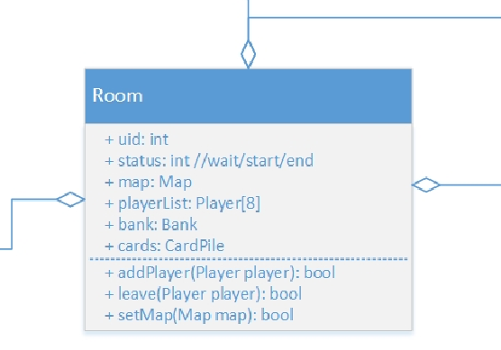

Room has all the information of a game.

Property, Map

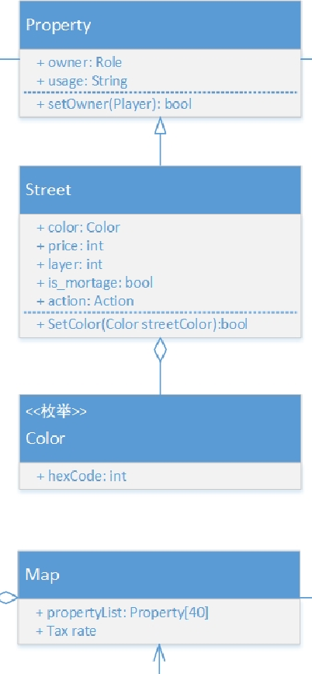

40 blocks in the map are extended from Property. Here we just list class Street, which other properties also will be construct like. We have an intrinsic owner called System whose property cannot be transfer.